1 User Model
Used for login and signup.

Methods
registerUser()
loginUser()
getUserById()
getAllUsers()
updateUser()
deleteUser()
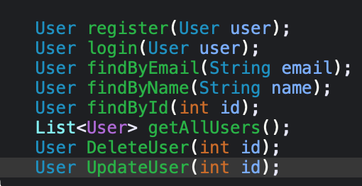Example flow:
- Signup → registerUser()
- Login → loginUser()

2 Complaint Model
Used when citizen raises issue.

Methods
createComplaint()
getAllComplaints()
getComplaintById()
getComplaintsByCitizen()
updateComplaint()
deleteComplaint()
Example:
Citizen raises complaint → createComplaint()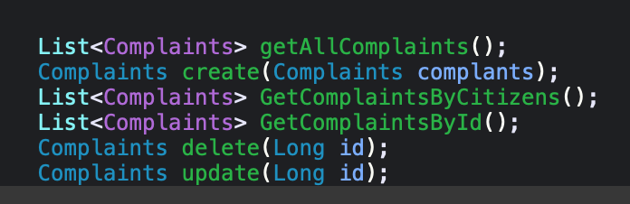

3 Employee Model
Used to manage employees.

Methods
addEmployee()
getAllEmployees()
getEmployeeById()
updateEmployee()
deleteEmployee()
Admin manages employees.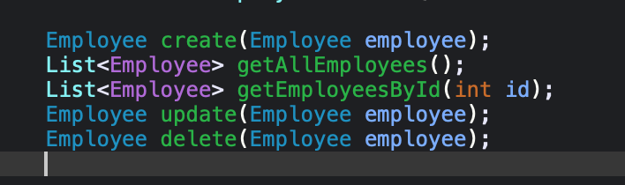

4 TaskAssignment Model
Admin assigns complaint to employee.

Methods
assignTask()
getAllAssignments()
getAssignmentsByEmployee()
updateAssignmentStatus()
deleteAssignment()
Example:
Admin assigns complaint → assignTask()

5 EmployeePerformance Model
Tracks employee work.

Methods
addPerformanceRecord()
getEmployeePerformance()
updatePerformance()
getAllPerformance()

6 CityInfo Model
Stores city information.

Methods
addCityInfo()
getCityInfo()
updateCityInfo()
deleteCityInfo()
Example:
Admin adds hospital info.

7 Weather Model
Stores weather data.

Methods
addWeather()
getWeatherByPlace()
getAllWeather()
updateWeather()
deleteWeather()

